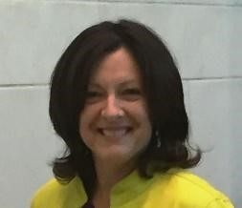
Trisha has been a Registered Nurse for twenty-five years. She connects with pregnant women in a personal, cheerful and caring way. At Mary’s House, she is the Clinic Director who can answer questions as a nurse and encourage you as a good friend would.

